**Project Design Phase-II Technology Stack (Architecture & Stack)**

|  |  |
| --- | --- |
| Date | 15th October 2022 |
| Team ID | PNT2022TMID18166 |
| Project Name | Analytics for Hospital Health-Care Data |
| Maximum Marks | 4 Marks |

**TECHNICAL ARCHITECTURE:**

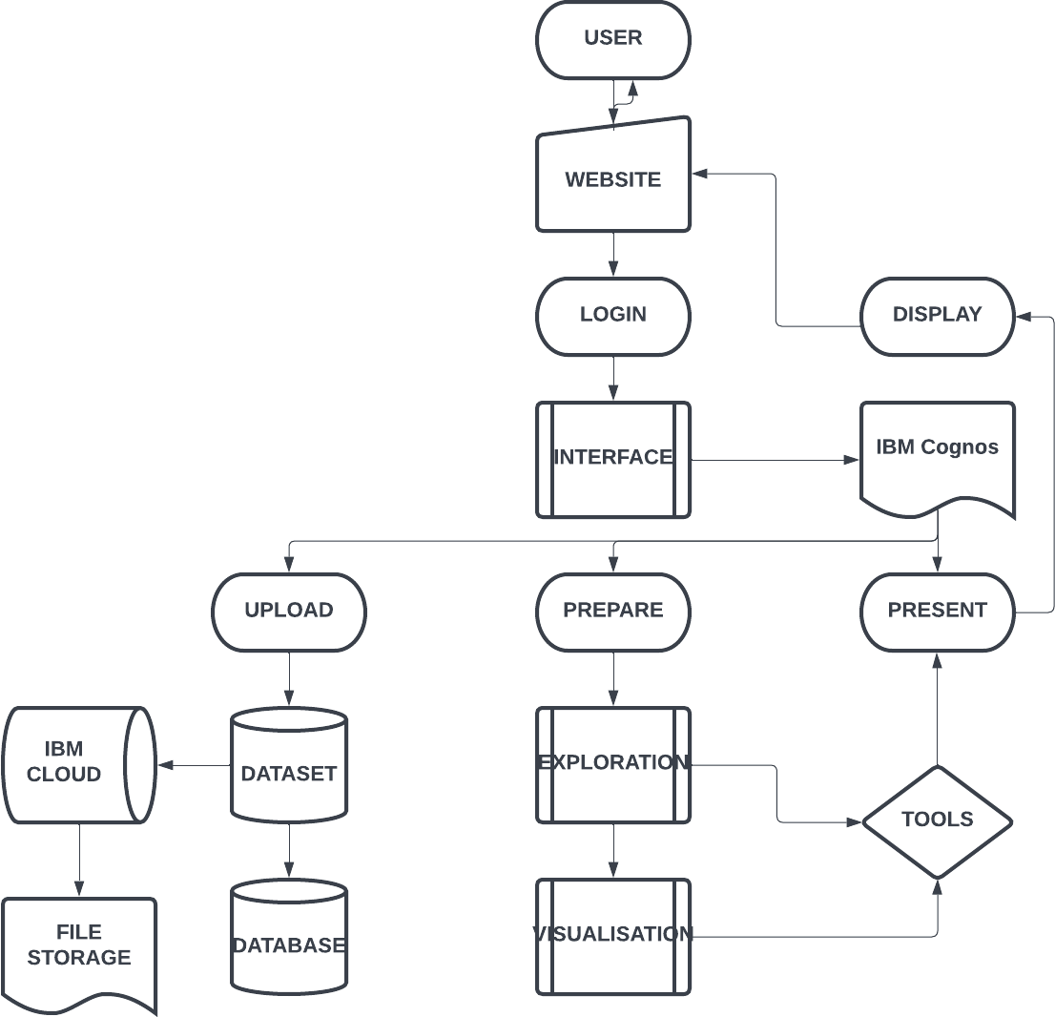

Table-1 : Components & Technologies:

|  |  |  |  |
| --- | --- | --- | --- |
| **S.No** | **Component** | **Description** | **Technology** |
| 1. | User Interface | How the user interacts with the interface e.g. Web UI,  etc. | HTML, CSS, JavaScript / Angular Js /  React Js etc. |
| 2. | Dashboard Logic-1 | Logic for a process in the dashboard | IBM Cognos Analytics |
| 3. | Dashboard Logic-2 | Logic for a process in the dashboard | MS Excel |
| 4. | Database | Data Type, Configurations etc. | MySQL, NoSQL, etc. |
| 5. | Cloud Database | Database Service on Cloud | IBM Cloud |
| 6. | File Storage | File storage requirements | IBM Block Storage or Other Storage  Service or Local Filesystem |
| 7. | Uploading and Presentation | Using Exploration and Visualization | IBM Cognos Analytics |

Table-2: Dashboard Characteristics:

|  |  |  |  |
| --- | --- | --- | --- |
| **S.No** | **Characteristics** | **Description** | **Technology** |
| 1. | Open-Source Frameworks | List the open-source frameworks used. | IBM Cognos |
| 2. | Security Implementations | List all the security / access controls implemented, use of firewalls etc. | Authentication and Authorization,Firewall,etc.. |
| 3. | Scalable Architecture | Justify the scalability of architecture (3 – tier, Micro-services) | 3-tier Architecture can be implemented so that the project can be worked by splitting up into 3 tiers namely presentation tier,  application tier, data tier. |
| 4. | Availability | Justify the availability of application (e.g. use of load balancers, distributed servers etc. | High availability enables your IT  infrastructure to continue functioning even when some of its components fail. |
| 5. | Performance | Design consideration for the performance of the application (number of requests per sec, use of Cache, use of CDN’s) etc. | A field of practice that uses various tools, processes, and ideas in a scientific manner to improve the desired outcomes of  individuals and organizations |